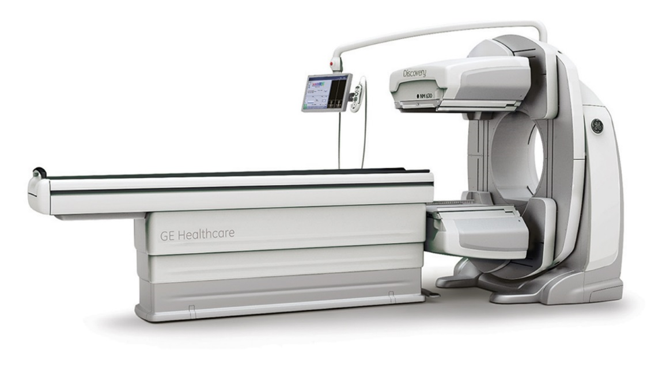
Hutchinson Clinic recently installed the GE Discovery NM630 Nuclear Camera.
GE leverages decades of experience in molecular imaging to provide exceptional levels of care for more patients.
The Elite NXT detectors enable exceptional image quality, while the thin design and auto-body contouring minimize the distance between the patient and the detectors for excellent resolution.

GE uses SPECT-optimized collimators combined with an exceptionally high count rate to enable extremely precise event detection. Below are some of the key features.

- Provides shorter, more tolerable exams for greater patient comfort with Evolution technology¹

- Improve your cardiac productivity by reducing scan time by half.

- Comfortably accommodate more patients with a patient-friendly system design.

- With a large bore and table capable of handling patients up to 500 pounds, Discovery NM630 is designed to maximize your scannable population.

