

Patient Information

Welcome

We are excited you have been referred by

Your Optometrist to the Hutchinson Clinic

Ophthalmology Department

**You will be seeing**

**Chad Denison, MD**

Conveniently located on the

main level just inside the north

doors of the building at

***2101 N. Waldron***

If you have any questions or

concerns about your appointment,

please call us directly at

**620.669.2592**

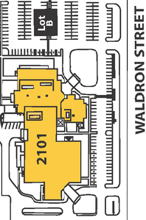

**Dr. Denison will work closely with your Optometrist to care for and preserve your vision to the best degree possible.**

Surgeries and Procedures:

Cataract

YAG laser

Glaucoma laser (SLT)

Botox (cosmetic and functional)

Office lid surgery (chalazion, lid lesions)

Functional Blepharoplasty (surgical repair or reconstruction of an eyelid)

Ocular Issues:

Glaucoma

Cataract

Diabetes

Age Related Macular Degeneration

For more information about Dr. Denison or the Hutchinson Clinic, please visit

[www.hutchclinic.com](http://www.hutchclinic.com)

We are looking forward to

seeing you soon!

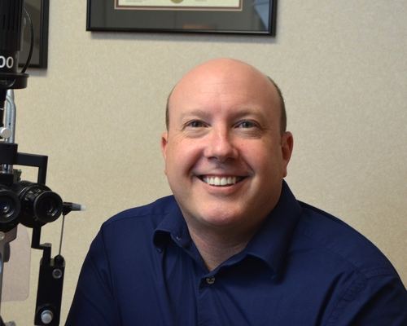





**Dr. Denison will work closely with your Optometrist to care for and preserve your vision to the best degree possible.**

Surgeries and Procedures:

Cataract

YAG laser

Glaucoma laser (SLT)

Botox (cosmetic and functional)

Office lid surgery (chalazion, lid lesions)

Functional Blepharoplasty (surgical repair or reconstruction of an eyelid)

Ocular Issues:

Glaucoma

Cataract

Diabetes

Age Related Macular Degeneration

For more information about Dr. Denison or the Hutchinson Clinic, please visit

[www.hutchclinic.com](http://www.hutchclinic.com)

We are looking forward to

seeing you soon!







Patient Information

Welcome

We are excited you have been referred by

Your Optometrist to the Hutchinson Clinic

Ophthalmology Department

**You will be seeing**

**Chad Denison, MD**

Conveniently located on the

main level just inside the north

doors of the building at

***2101 N. Waldron***

If you have any questions or

concerns about your appointment,

please call us directly at

**620.669.2592**









Patient Information

Welcome

We are excited you have been referred by

Your Optometrist to the Hutchinson Clinic

Ophthalmology Department

**You will be seeing**

**Chad Denison, MD**

Conveniently located on the

main level just inside the north

doors of the building at

***2101 N. Waldron***

If you have any questions or

concerns about your appointment,

please call us directly at

**620.669.2592**



